Setting up Databricks:

- Created Databricks
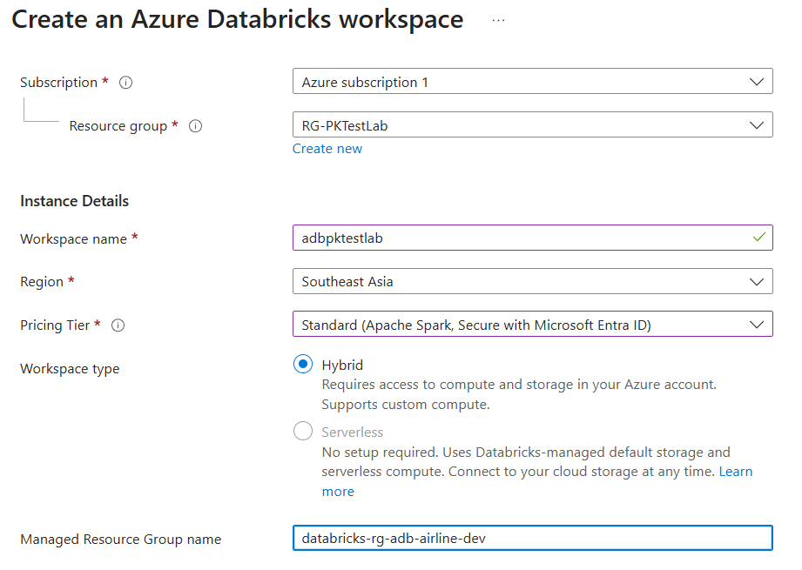

- At first, I created databricks connector (Unity Catalog) which should dealt with connecting to ADLS after adding in the IAM Role.
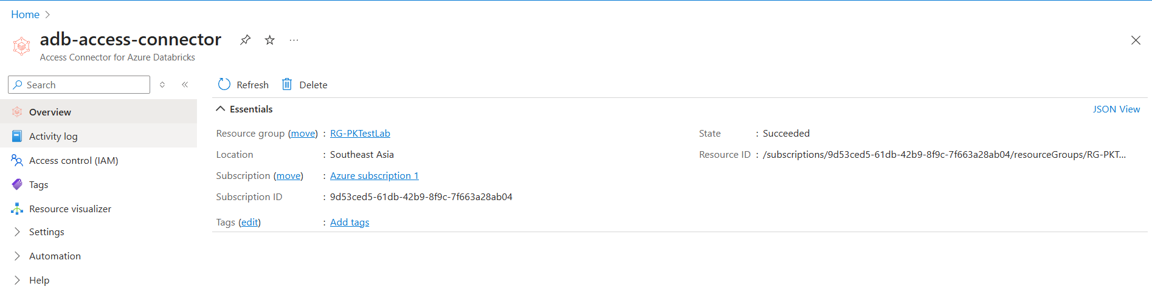

Connection created using this documentation:
https://learn.microsoft.com/en-us/azure/databricks/connect/storage/tutorial-azure-storage
Created Cluster / Compute node (basic level) for small data processing
Name: learning-small-cluster

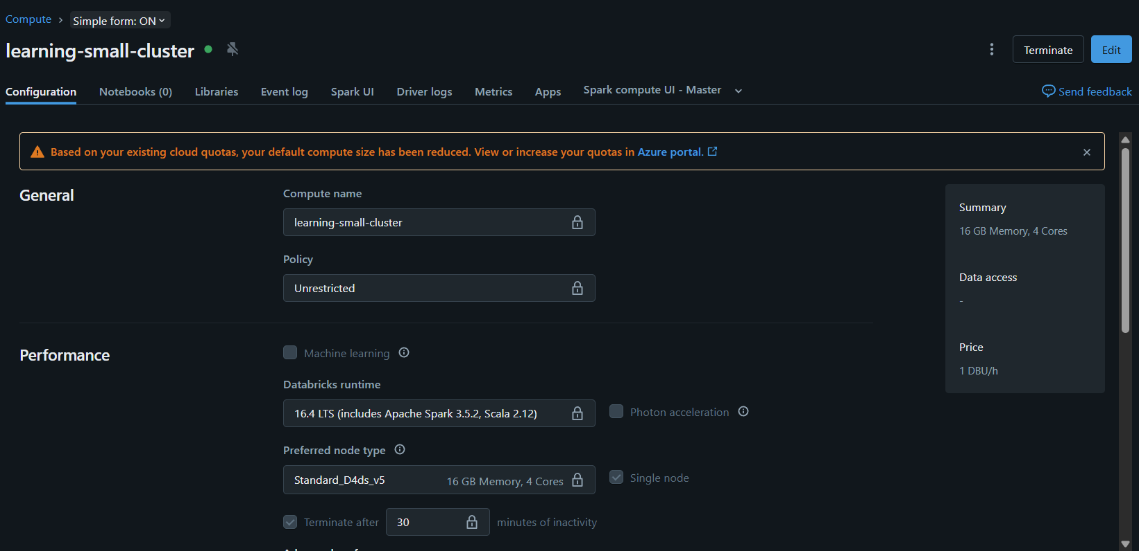

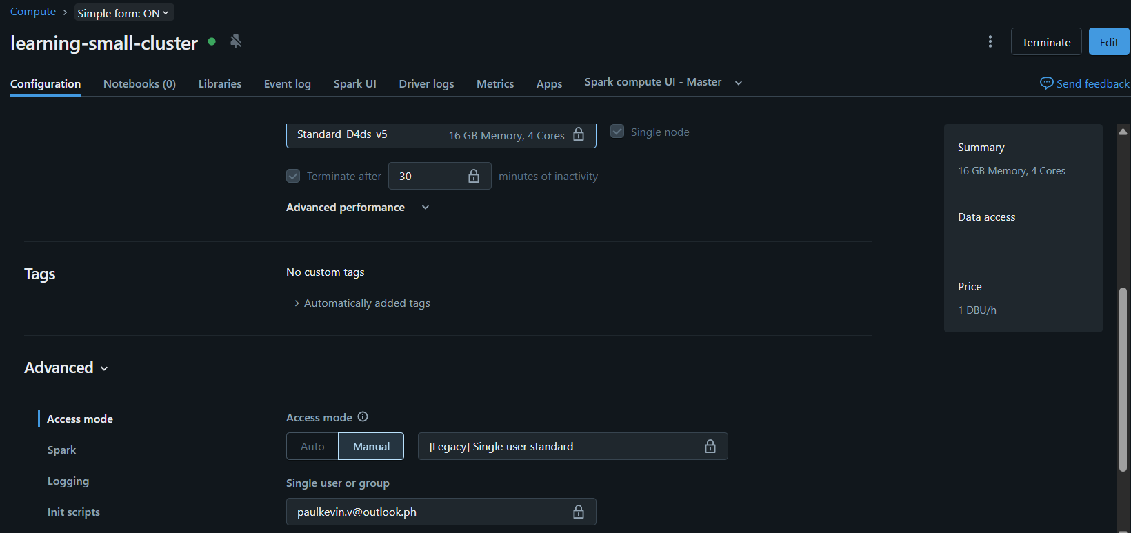

However, I encountered an error saying:
“Failure to initialize configuration for storage account datalakepktestlab.dfs.core.windows.net: Invalid configuration value detected for fs.azure.account.keyInvalid configuration value detected for fs.azure.account.key at shaded.databricks.azurebfs.org.apache.hadoop.fs.azurebfs.services.SimpleKeyProvider.getStorageAccountKey(SimpleKeyProvider.java:52) at shaded.databricks.azurebfs.org.apache.hadoop.fs.azurebfs.AbfsConfiguration.getStorageAccountKey(AbfsConfiguration.java:730) at shaded.databricks.azurebfs.org.apa”

Create Secret Scope in Databricks (UI Method)
https://<databricks-instance>#secrets/createScope

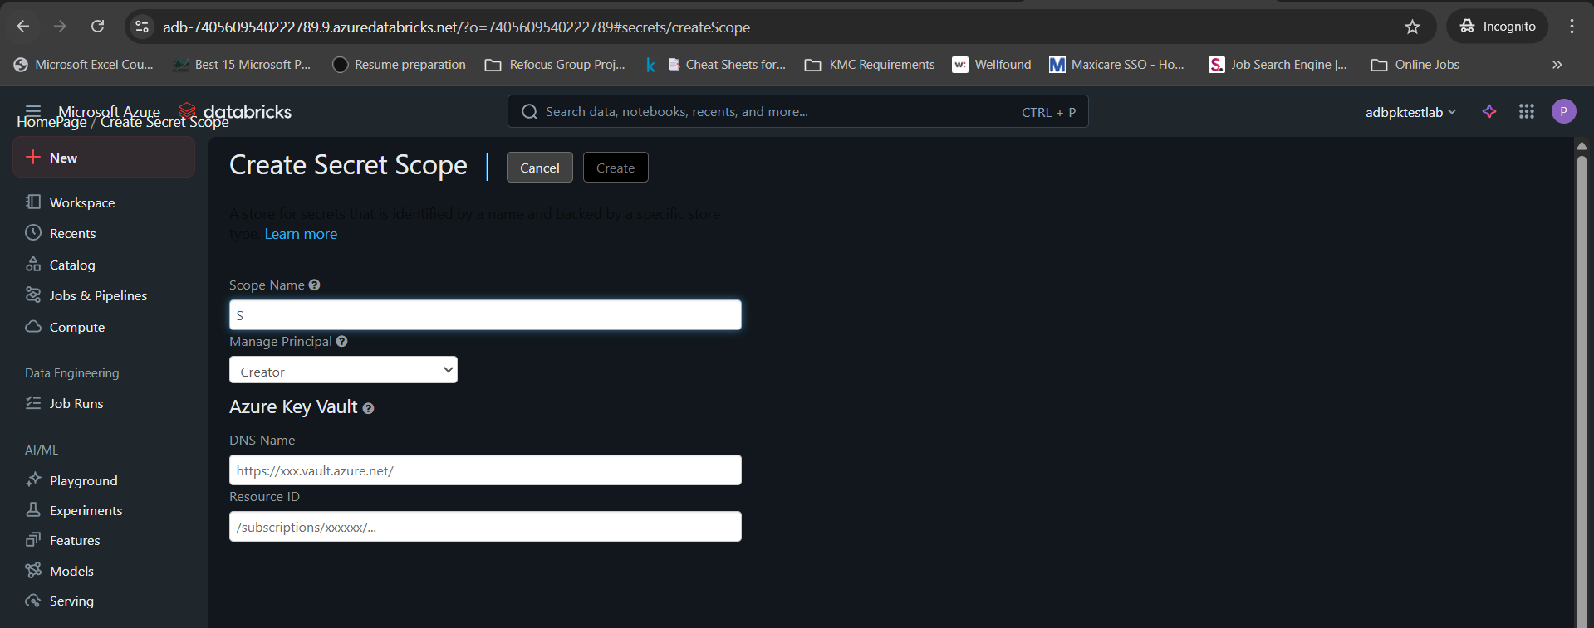

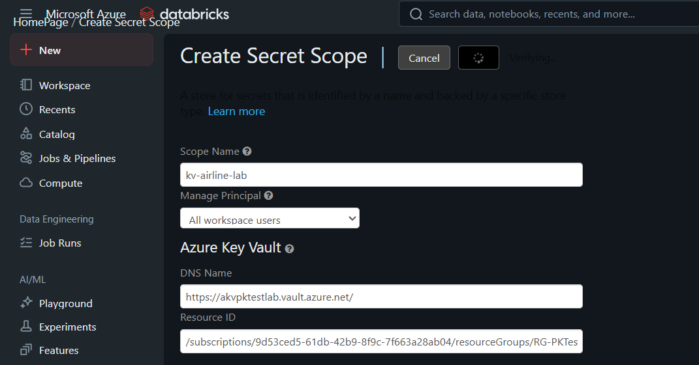

Create secret scope

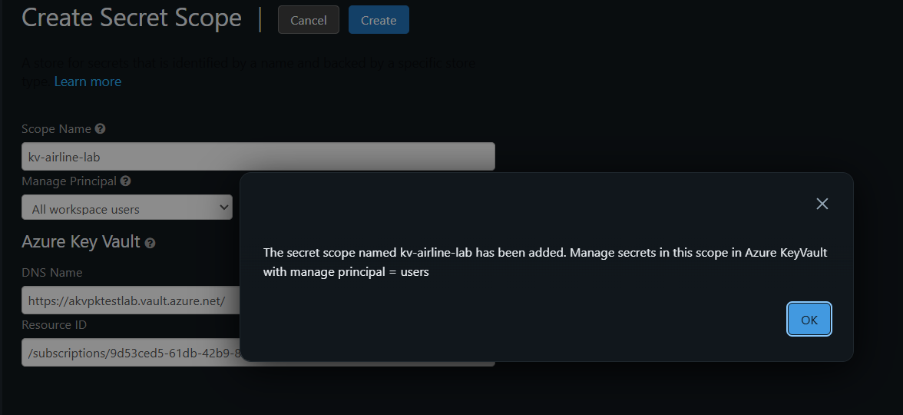

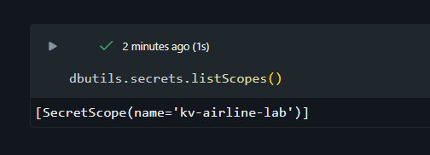

Understand: Add the AppID , if not app ID then Object ID .

Understand: Use dbutils.secrets.get to fetch the key from the key vault using the scope name created.
Should see '[REDACTED]'
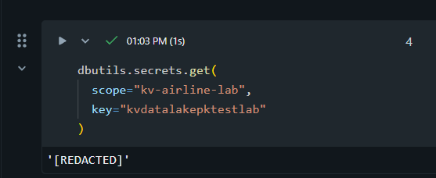

This means:
- You are NOT using Unity Catalog yet
- Key Vault + storage key is the correct method
- Managed Identity / Access Connector is not required

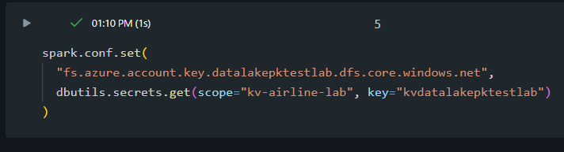

Check if the file is available.
Uses dbutils.fs.ls(“abfss url”)

